1-Single Page Application

🖥️ What Is a Single Page Application (SPA)?
# Source: Chatgpt (GPT‑5 Mini) at [1/14/2026]
A Single Page Application (SPA) is a web application that loads a single HTML page and dynamically updates the content without reloading the entire page when the user interacts with it.

✅ Simple Definition:
# Source: Chatgpt (GPT‑5 Mini) at [1/14/2026]
A SPA is a website that acts more like an app — it loads once and updates content via JavaScript without refreshing the whole page.

🧠 Real-Life Analogy:
# Source: Chatgpt (GPT‑5 Mini) at [1/14/2026]
Think of a mobile app:
- You tap around, open pages, view data
- But the app doesn’t reload or blink — it just changes content smoothly
A SPA behaves similarly, but in the browser.

🔄 How It Works
# Source: Chatgpt (GPT‑5 Mini) at [1/14/2026]
- User visits the SPA → browser downloads:
  - index.html
  - CSS
  - JavaScript files
- The app renders UI with JavaScript (e.g. React, Vue, Angular)
- When a user clicks a link or interacts:
  - The app fetches only the needed data (via AJAX / APIs)
  - Updates the DOM without full-page reload

⚙️ Technologies Used
# Source: Chatgpt (GPT‑5 Mini) at [1/14/2026]
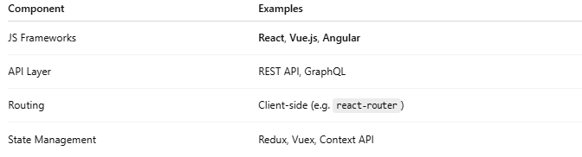

Component | Examples
JS Frameworks | React, Vue.js, Angular
API Layer | REST API, GraphQL
Routing | Client-side (e.g. react-router)
State Management | Redux, Vuex, Context API

🧾 Example: SPA vs MPA
# Source: Chatgpt (GPT‑5 Mini) at [1/14/2026]

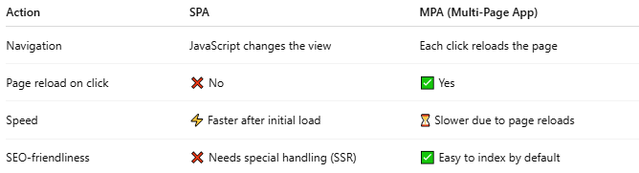

Action | SPA | MPA (Multi-Page App)
Navigation | JavaScript changes the view | Each click reloads the page
Page reload on click | ❌ No | ✅ Yes
Speed | ⚡ Faster after initial load | ⏳ Slower due to page reloads
SEO-friendliness | ❌ Needs special handling (SSR) | ✅ Easy to index by default

📦 Example SPA Apps
# Source: Chatgpt (GPT‑5 Mini) at [1/14/2026]
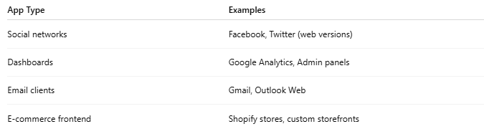

App Type | Examples
Social networks | Facebook, Twitter (web versions)
Dashboards | Google Analytics, Admin panels
Email clients | Gmail, Outlook Web
E-commerce frontend | Shopify stores, custom storefronts

✅ Advantages of SPA
# Source: Chatgpt (GPT‑5 Mini) at [1/14/2026]
- ⚡ Fast navigation (no full reloads)
- 📱 App-like experience
- 🔄 Efficient API usage (only fetch data)
- 🎨 Better UI control and animations

❌ Disadvantages of SPA
# Source: Chatgpt (GPT‑5 Mini) at [1/14/2026]
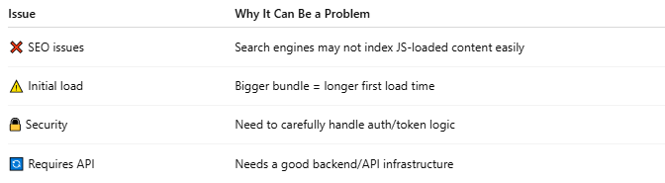

Issue | Why It Can Be a Problem
❌ SEO issues | Search engines may not index JS-loaded content easily
⚠️ Initial load | Bigger bundle = longer first load time
🔒 Security | Need to carefully handle auth/token logic
🔄 Requires API | Needs a good backend/API infrastructure

📌 Summary
# Source: Chatgpt (GPT‑5 Mini) at [1/14/2026]
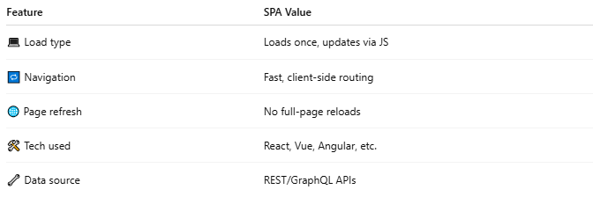

Feature | SPA Value
💻 Load type | Loads once, updates via JS
🔁 Navigation | Fast, client-side routing
🌐 Page refresh | No full-page reloads
🛠️ Tech used | React, Vue, Angular, etc.
🔧 Data source | REST/GraphQL APIs

2-Multi-Page Application

🗂️ What Is a Multi-Page Application (MPA)?
# Source: Chatgpt (GPT‑5 Mini) at [1/14/2026]
A Multi-Page Application (MPA) is a traditional web application where each page is a separate HTML file. When the user navigates to a different part of the site, the browser reloads the entire page from the server.

✅ Simple Definition:
# Source: Chatgpt (GPT‑5 Mini) at [1/14/2026]
A Multi-Page App reloads the browser and loads a new HTML page every time you click a link or change routes.

🧠 Real-Life Analogy:
# Source: Chatgpt (GPT‑5 Mini) at [1/14/2026]
Think of flipping pages in a physical book:
- Each new page has its own content
- Turning the page (clicking a link) replaces the whole view
- That’s how MPAs work

🧾 Example Sites
# Source: Chatgpt (GPT‑5 Mini) at [1/14/2026]
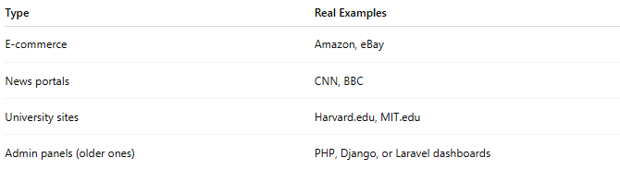

Type | Real Examples
E-commerce | Amazon, eBay
News portals | CNN, BBC
University sites | Harvard.edu, MIT.edu
Admin panels (older ones) | PHP, Django, or Laravel dashboards

🔁 How It Works
# Source: Chatgpt (GPT‑5 Mini) at [1/14/2026]
- User clicks a link (e.g. /about)
- Browser sends request to the server
- Server returns a full HTML page (about.html)
- Browser completely reloads
- Any scripts and stylesheets are reloaded again

⚙️ Technologies Used
# Source: Chatgpt (GPT‑5 Mini) at [1/14/2026]
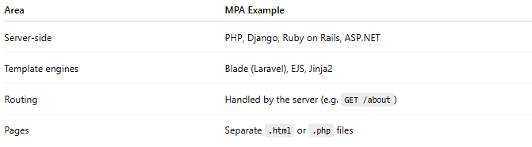

Area | MPA Example
Server-side | PHP, Django, Ruby on Rails, ASP.NET
Template engines | Blade (Laravel), EJS, Jinja2
Routing | Handled by the server (e.g. GET /about)
Pages | Separate .html or .php files

🔄 MPA vs SPA
# Source: Chatgpt (GPT‑5 Mini) at [1/14/2026]
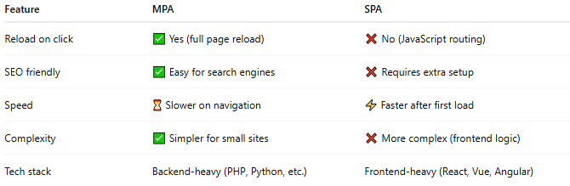

Feature | MPA | SPA
Reload on click | ✅ Yes (full page reload) | ❌ No (JavaScript routing)
SEO friendly | ✅ Easy for search engines | ❌ Requires extra setup
Speed | ⏳ Slower on navigation | ⚡ Faster after first load
Complexity | ✅ Simpler for small sites | ❌ More complex (frontend logic)
Tech stack | Backend-heavy (PHP, Python, etc.) | Frontend-heavy (React, Vue, Angular)

✅ Advantages of MPA
# Source: Chatgpt (GPT‑5 Mini) at [1/14/2026]
- ✅ Great SEO (search bots read static HTML easily)
- ✅ Simple architecture (easier for small projects)
- ✅ Better for large content sites (e.g. news, e-commerce)
- ✅ Server-side rendering by default

❌ Disadvantages of MPA
# Source: Chatgpt (GPT‑5 Mini) at [1/14/2026]
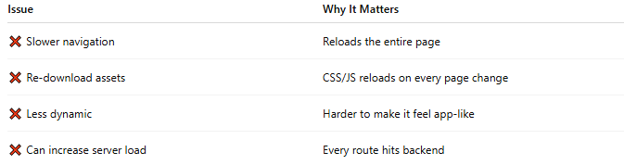

Issue | Why It Matters
❌ Slower navigation | Reloads the entire page
❌ Re-download assets | CSS/JS reloads on every page change
❌ Less dynamic | Harder to make it feel app-like
❌ Can increase server load | Every route hits backend

📌 Summary
# Source: Chatgpt (GPT‑5 Mini) at [1/14/2026]
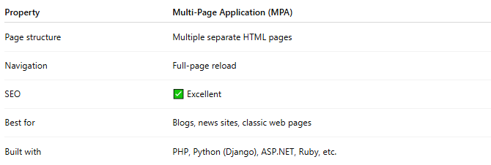

Property | Multi-Page Application (MPA)
Page structure | Multiple separate HTML pages
Navigation | Full-page reload
SEO | ✅ Excellent
Best for | Blogs, news sites, classic web pages
Built with | PHP, Python (Django), ASP.NET, Ruby, etc.

